1 | P a g

Technical & Financial Proposal
Of
Purchase, Inventory, Sales, CRM, Accounting & Employee Role Management Modules for Depot Management Software
Of

A sister concern of

Date: 13th February, 2019

2019
Submitted By
Venus IT Limited

1 | Page

13th February, 2019

To

Abu Hena Mastafa Kamal
CEO
KFMAL (Krishibid Farm Machinery and Automobile Limited)
Krishibid Group
Mobile: 01938849266
E-Mail: ahkamal@grishibidgroup.com

Subject: Proposal of Purchase, Inventory, Sales, CRM & Accounting & Employee Role Management Module into Depot Management Software for KFMAL (Krishibid Farm Machinery and Automobile Limited)

Dear Sir,

We would like to take the opportunity to submit the Technical & Financial Proposal for your company as well as the opportunity to work with you.

Here at Venus IT Limited we are always excited about working with new projects and clients, and building new bridges. Developing Inventory, Sales, CRM, Accounting, and Depot & Employee Role Management Software is a professional task. It requires experience, creativity, and profound technical knowledge, and we have all the resources necessary to blend these three.

We have carefully studied your requirements and have a firm understanding of what needs to be done in order to accomplish your goals. As with every case study, we take our time, come up with the most cost-effective solution through a number of brainstorming session, and submit you a proposal that will hopefully be the best proposal to bring out the productivity through web application of KFMAL (Krishibid Farm Machinery and Automobile Limited).

I hope you find this proposal very complete and innovative. We take pride in being different and creative. If you have any questions, queries, or simply want to talk more to us regarding any matter, do feel free to drop a question and we will answer that promptly.

Sincerely,

Md. Nasir Uddin
Director of Operations

Venus IT Limited
Venus Complex (13th Floor)

Bir Uttam Rafiqul Islam Avenue

Middle Badda, Dhaka-1212, Bangladesh

Mobile: +88 01700619263, +88 01708872244

Email address: nasir.venusitltd@gmail.com & nasir@venusitltd.com

Budget Control Analysis & Project Completion Date:

Budget Control Analysis:

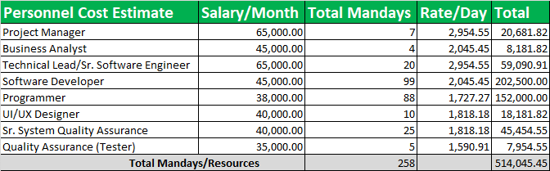
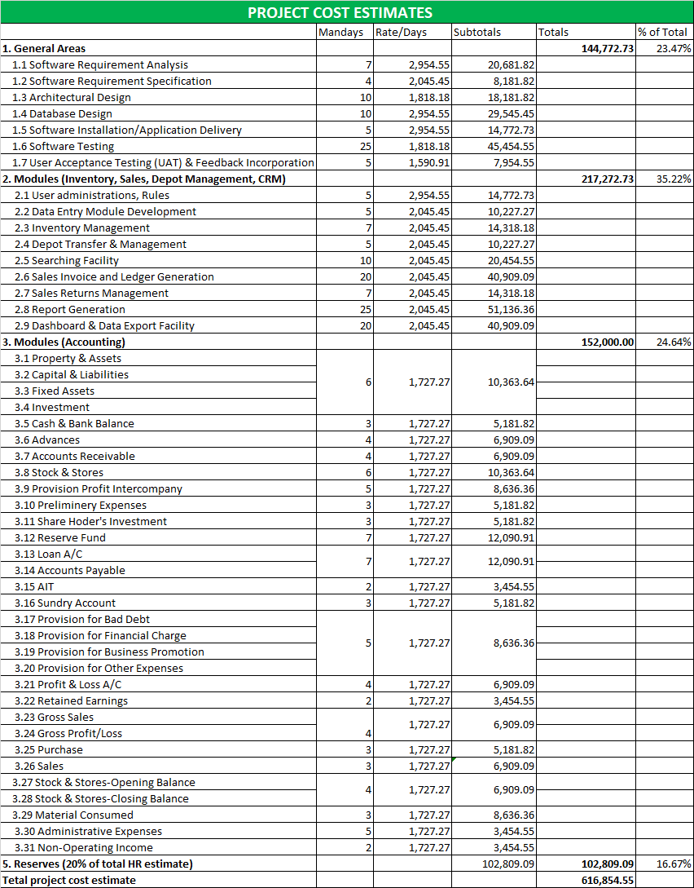 * See Mandays and Personnel Cost Estimate
Project Completion Date

Total development duration is 6-7 months. Please note that weekends and holidays are excluded in the schedule. Any public holidays and announced no-work day will affect our schedule and extend the corresponding deadlines using a ratio of one-is-to-one.

Total Price Breakdown & Payment Schedule:

Total Price Breakdown:

*Payment amounts under this package do not include VAT & Server Cost; Services are subject to 5.5% VAT (Value Added Tax) & Server cost is yearly 12,000 Taka only.

*Venus IT Limited would provide Purchase, Inventory, Sales, CRM, Accounting, Employee Role Management, Depot Management Software (Total Solutions according to agreement) development to Client (KFMAL) for BDT 617,000 (Six Lakh & Seventeen Thousand Taka Only).

Payment Schedule:

Sl. No | Amount | Percentage | Time
1. | BDT 277,650 | 45% | Immediate (at the time of work order)
2. | BDT 246,800 | 40% | In the beginning of 3rd Month from start
3. | BDT 92,550 | 15% | After Full Delivery of All Modules

Payment Procedure:
- Payment will goes to VENUS IT Accounts pay Cheque.

Support & Maintenance:
- Free Support & Maintenance: 3 month
- Support & Maintenance Charge after 3 month: 12,000 taka per year
Training:
- 1st training: Free
- 2nd training & others: 1000 taka(In Venus IT Ltd), 2000 taka(In client's office)

Sample Work Order

Date:

To

Md. Nasir Uddin
Director of Operations
Venus IT Limited
Venus Complex (12th Floor)

Bir Uttam Rafiqul Islam Avenue

Middle Badda, Dhaka-1212, Bangladesh

Mobile: +88- 0170 8872244 & 01700 619263

Email address: nasir.venusitltd@gmail.com & coo@venusitltd.com

Subject: Work Order for Inventory, Depot, Sales, Accounting & Customer Management Software for KFMAL.

This refers to your offer Ref No.000000 Date: --/--/-- and the subsequent discussions that had the undersigned with you on the above subject. We are pleased to inform you that the management of KFMAL (Krishibid Farm Machinery and Automobile Limited) has approved your proposal for Purchase, Inventory, Sales, CRM, Accounting & Employee Role Management and Depot Management Software with the following terms and conditions.

Terms and Conditions:

- The total valuation of the projects is Six Lakh & Seventeen Thousand Taka (BDT 617,000) only.

- Payment 45% in Advanced at the time of work order.

- KFMAL will pay another 55% in two installments (40% & 15%).

- Venus IT Limited will provide 6-month free service from the date of Service Delivery.

- KFMAL will pay 12,000 (Twelve Thousand) Taka/year as a service & maintenance cost after the expiration date of free service.

Thanks and best regards.

Abu Hena Mastafa Kamal
CEO
KFMAL (Krishibid Farm Machinery and Automobile Limited)
Krishibid Group
Mobile: 01938849266
E-Mail: ahkamal@grishibidgroup.com

